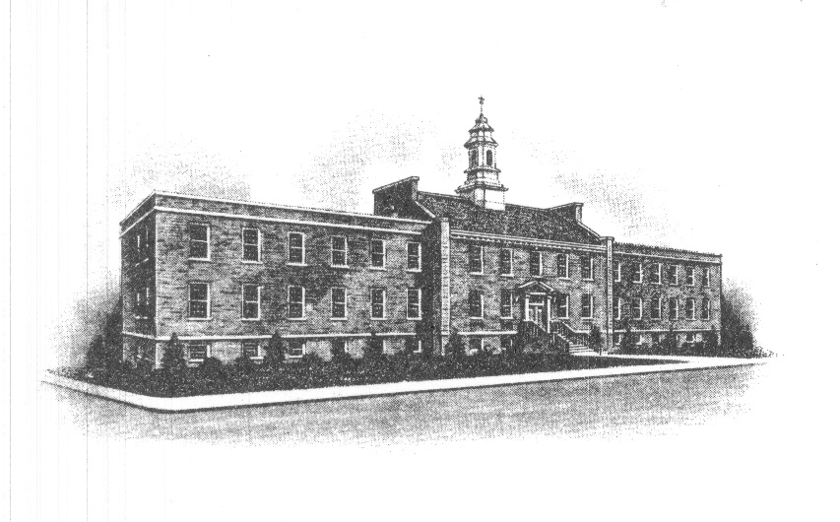
The Borough of Sayreville
Sayreville Board of Adjustment
167 Main Street
Sayreville, NJ 08872
(732) 390-7077 - Phone
(732) 390-7458 - Fax

ZONING BOARD MEETING CANCELLATION ANNOUNCEMENT

Take notice that the regularly scheduled Reorganization and Regular meetings for February 22, 2023, of the Zoning Board of Adjustment in the Borough of Sayreville, N.J. has been cancelled and there will be no further notice necessary by the applicants to adjacent property owners.

The next meeting will take place on March 22, 2023 at 7:00 PM at which time the Board will have its Reorganization followed by the Regular Meeting for the submitted applications. The scheduled meeting will be held in the Council Chambers on the 3rd Floor in Borough Hall, 167 Main Street, Sayreville, NJ 08872.

Notice of the March 22, 2023 meeting will be posted on the Borough Website and on the bulletin board in Borough Hall, and noticed in The Home News Tribune. All applications, plans and documents related to the application(s) on the posted agenda will be available for review on the Borough website (www.sayreville.com) and in the Construction/Zoning Office located at 49 Dolan Street, Sayreville, NJ during normal working hours 7:30 AM – 3:00 PM by contacting Joan M. Kemble, Board Secretary at 732-390-7077.

Joan M. Kemble
Secretary
Zoning Board of Adjustment

